Unbounded Region in Solid Geometry

Definition
# Source: AI Source: Provided by: [Data Path: Persons Table -> ID Column: 1, Name_En Column: Motasem Essam] -> From: [ChatGPT] on [7/25/2026]
An unbounded region in solid geometry is a region of three-dimensional space that extends arbitrarily far from a fixed point in at least one direction. No matter how large a finite sphere or box is chosen, some points of the region will lie outside it.
An unbounded region may extend in one direction, several directions, or infinitely in every direction. It can have flat boundaries, curved boundaries, or no boundary at all.
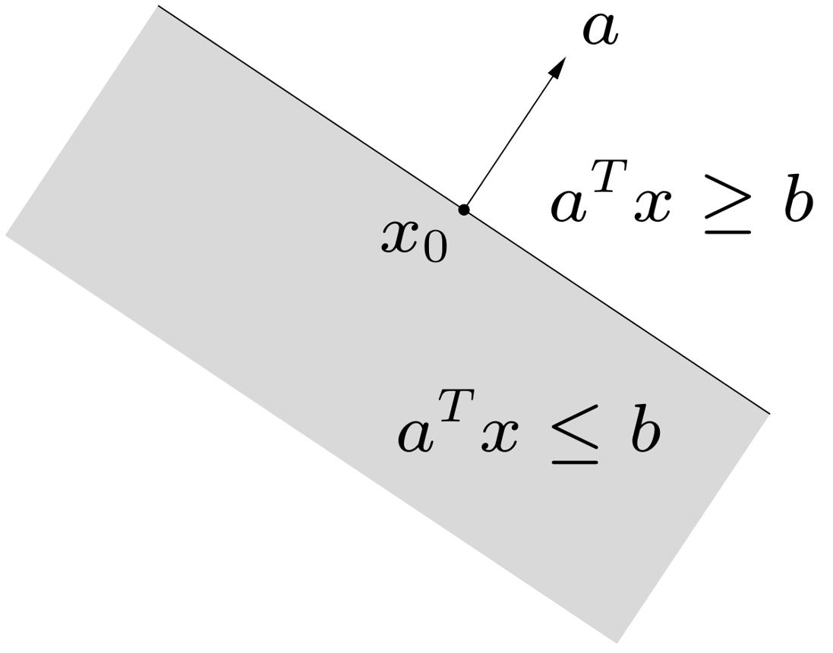
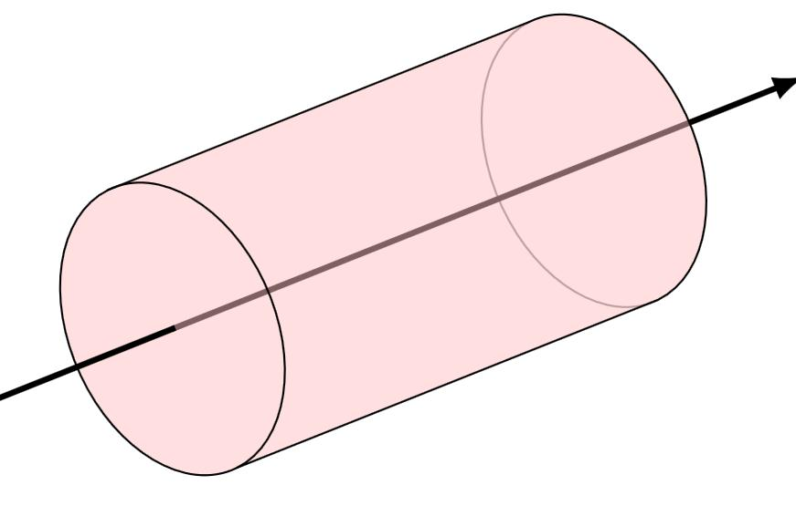
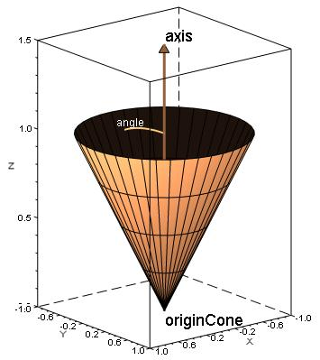

Simple Definition
# Source: AI Source: Provided by: [Data Path: Persons Table -> ID Column: 1, Name_En Column: Motasem Essam] -> From: [ChatGPT] on [7/25/2026]
An unbounded region is a region of space that continues indefinitely in at least one direction.
Examples include:
- The half-space above a horizontal plane.
- An infinite cylinder extending along an axis.
- An infinite cone extending indefinitely.
- The entire three-dimensional coordinate space.
Unlike a bounded region, an unbounded region cannot fit entirely inside any sphere of finite radius.

Key Characteristics
# Source: AI Source: Provided by: [Data Path: Persons Table -> ID Column: 1, Name_En Column: Motasem Essam] -> From: [ChatGPT] on [7/25/2026]
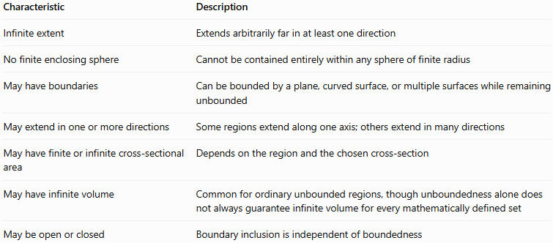
Characteristic | Description
Infinite extent | Extends arbitrarily far in at least one direction
No finite enclosing sphere | Cannot be contained entirely within any sphere of finite radius
May have boundaries | Can be bounded by a plane, curved surface, or multiple surfaces while remaining unbounded
May extend in one or more directions | Some regions extend along one axis; others extend in many directions
May have finite or infinite cross-sectional area | Depends on the region and the chosen cross-section
May have infinite volume | Common for ordinary unbounded regions, though unboundedness alone does not always guarantee infinite volume for every mathematically defined set
May be open or closed | Boundary inclusion is independent of boundedness
Important: Unbounded does not mean that a region has no boundary. A half-space has a boundary plane, and an infinite cylinder has a curved boundary surface, yet both are unbounded.

Geometric Representation
# Source: AI Source: Provided by: [Data Path: Persons Table -> ID Column: 1, Name_En Column: Motasem Essam] -> From: [ChatGPT] on [7/25/2026]
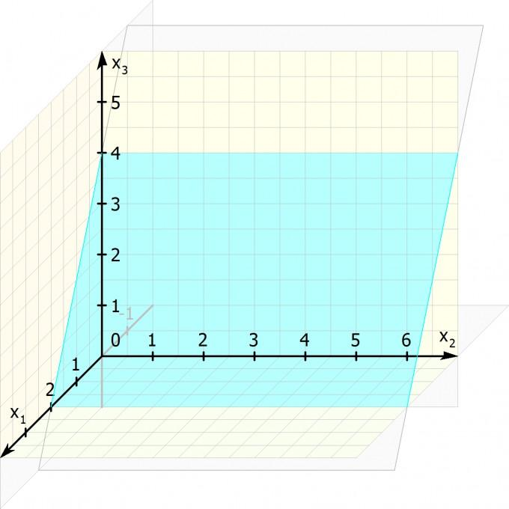
The following examples show how unbounded regions can extend beyond any finite viewing window.
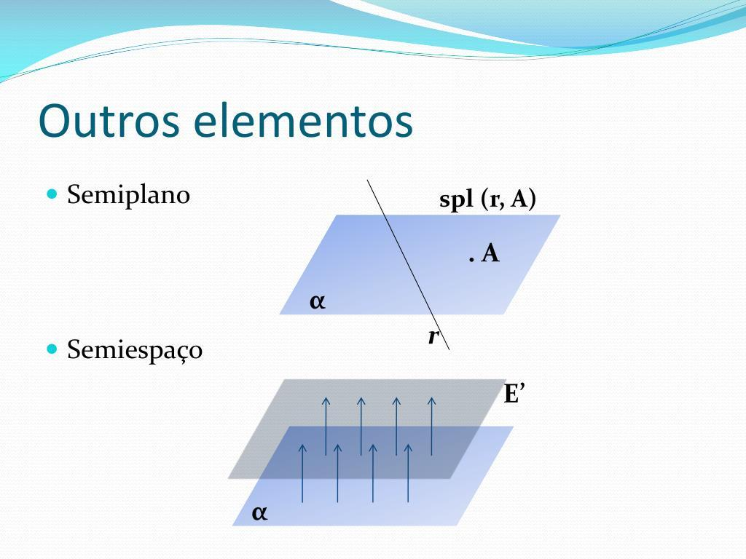
Half-space
Includes all points on one side of a plane. It extends indefinitely in the directions parallel to the plane and away from it.
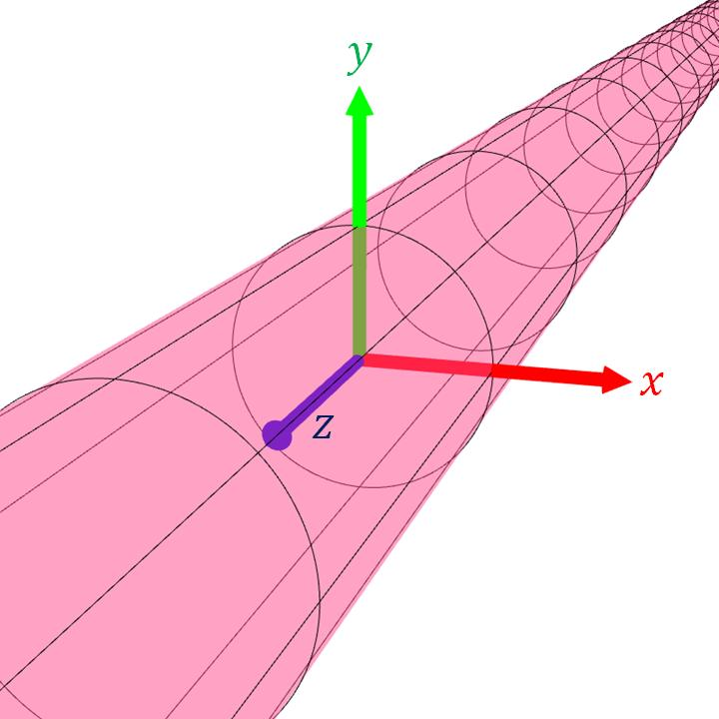
Infinite cylinder
Has a fixed circular cross-section but extends without limit along its axis.
Infinite cone
Widens as it extends indefinitely away from its vertex.
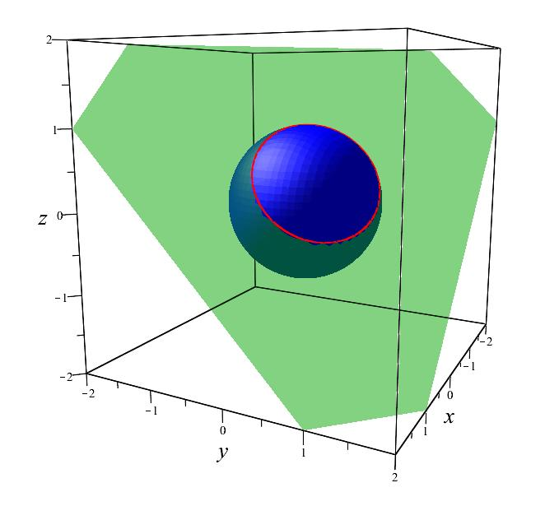
Exterior of a sphere
The region outside a sphere extends indefinitely away from the sphere in every direction.

Mathematical Representation

General definition of unboundedness
# Source: AI Source: Provided by: [Data Path: Persons Table -> ID Column: 1, Name_En Column: Motasem Essam] -> From: [ChatGPT] on [7/25/2026]
Let $R$ be a region in three-dimensional Cartesian space. The region is unbounded if, for every finite number $M>0$, there is at least one point $P∈R$ whose distance from a fixed reference point $P_{0}$ exceeds $M$.
$$∀M>0, ∃P∈R:\operatorname{dist}\left(P,P_{0}\right)>M$$
If $P=\left(x,y,z\right)$ and the reference point is the origin, this becomes
$$\sqrt{x^{2}+y^{2}+z^{2}}>M$$
for some point in the region, no matter how large $M$ is chosen.

Example: A half-space
# Source: AI Source: Provided by: [Data Path: Persons Table -> ID Column: 1, Name_En Column: Motasem Essam] -> From: [ChatGPT] on [7/25/2026]
Consider the region
$$z≥0$$
This describes the half-space on or above the $xy$-plane.
The region is unbounded because $z$ can increase without limit. Its points can also extend indefinitely in the $x$- and $y$-directions.

Example: An infinite cylinder
# Source: AI Source: Provided by: [Data Path: Persons Table -> ID Column: 1, Name_En Column: Motasem Essam] -> From: [ChatGPT] on [7/25/2026]
Consider the region
$$x^{2}+y^{2}≤9$$
with no restriction on $z$.
The distance from the $z$-axis is at most $3$, but the coordinate $z$ can take any real value:
$$-∞<z<∞$$
Therefore, the cylinder is unbounded along its axis.

Example: The exterior of a sphere
# Source: AI Source: Provided by: [Data Path: Persons Table -> ID Column: 1, Name_En Column: Motasem Essam] -> From: [ChatGPT] on [7/25/2026]
Consider the region
$$x^{2}+y^{2}+z^{2}>25$$
This describes all points whose distance from the origin is greater than $5$.
There is no maximum distance from the origin, so the exterior region is unbounded.
Note that this inequality excludes the sphere's surface. Using $≥25$ instead would include the surface, without changing the region's unboundedness.

Worked Examples
# Source: AI Source: Provided by: [Data Path: Persons Table -> ID Column: 1, Name_En Column: Motasem Essam] -> From: [ChatGPT] on [7/25/2026]
Example 1: Determine whether a region is unbounded
Consider
$$x≥0, y≥0, z≥0$$
Solution:
The region occupies the first octant, including its boundary planes.
All three coordinates can increase without limit. For any finite distance, we can choose a point in the region farther away from the origin.
Therefore, the region is unbounded.
Example 2: Determine whether a half-space is unbounded
Consider
$$x≤4$$
Solution:
This inequality describes all points on or to one side of the plane $x=4$.
Although the $x$-coordinate has an upper limit, it can decrease indefinitely. The $y$- and $z$-coordinates can also take arbitrarily large positive or negative values.
Therefore, the region is unbounded.
Example 3: Determine whether a cylinder is unbounded
Consider
$$x^{2}+y^{2}≤16$$
with $z$ unrestricted.
Solution:
The inequality restricts the distance from the $z$-axis to at most $4$. However, there is no limit on how far the region extends along the $z$-axis.
Therefore, the region is an unbounded cylinder.
Example 4: Determine whether the exterior of a ball is unbounded
Consider
$$x^{2}+y^{2}+z^{2}≥9$$
Solution:
The inequality describes all points on or outside a sphere of radius $3$ centered at the origin.
Points can be located at distances of $10$, $100$, $1,000$, or more units from the origin.
Therefore, the region is unbounded.

Comparison With Related Concepts
# Source: AI Source: Provided by: [Data Path: Persons Table -> ID Column: 1, Name_En Column: Motasem Essam] -> From: [ChatGPT] on [7/25/2026]
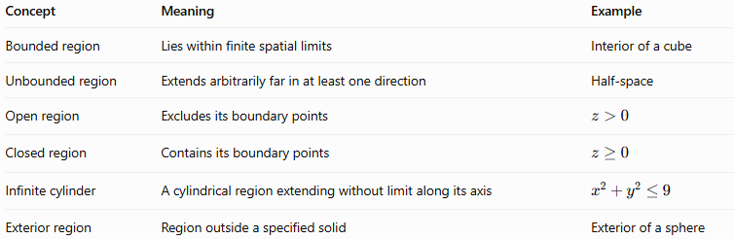
Concept | Meaning | Example
Bounded region | Lies within finite spatial limits | Interior of a cube
Unbounded region | Extends arbitrarily far in at least one direction | Half-space
Open region | Excludes its boundary points | $$z>0$$
Closed region | Contains its boundary points | $$z≥0$$
Infinite cylinder | A cylindrical region extending without limit along its axis | $$x^{2}+y^{2}≤9$$
Exterior region | Region outside a specified solid | Exterior of a sphere
An unbounded region may be open or closed. For example, both $z>0$ and $z≥0$ describe unbounded regions; the difference is whether the boundary plane is included.

Applications
# Source: AI Source: Provided by: [Data Path: Persons Table -> ID Column: 1, Name_En Column: Motasem Essam] -> From: [ChatGPT] on [7/25/2026]
- Analytic geometry: Describing half-spaces and regions defined by inequalities.
- Calculus: Studying improper integrals and integration over infinite domains.
- Computer graphics: Representing infinite planes, viewing spaces, and exterior regions.
- Physics: Modeling idealized spaces extending indefinitely.
- Engineering: Representing simplified environments and regions outside finite objects.
- Optimization: Defining feasible regions that may or may not have finite limits.

Key Points
# Source: AI Source: Provided by: [Data Path: Persons Table -> ID Column: 1, Name_En Column: Motasem Essam] -> From: [ChatGPT] on [7/25/2026]
- An unbounded region extends arbitrarily far in at least one direction.
- It cannot be contained entirely within a sphere of finite radius.
- It may have a flat or curved boundary.
- A half-space, infinite cylinder, infinite cone, and the exterior of a sphere are common examples.
- Unboundedness is independent of whether a region includes its boundary.
- An unbounded region does not necessarily have an infinite cross-sectional area, although many common unbounded regions have infinite volume.

Conclusion
# Source: AI Source: Provided by: [Data Path: Persons Table -> ID Column: 1, Name_En Column: Motasem Essam] -> From: [ChatGPT] on [7/25/2026]
An unbounded region in solid geometry is a portion of three-dimensional space that has no finite limit in at least one direction. It may extend along an axis, away from a plane, or outward from a solid. Recognizing unbounded regions helps distinguish finite geometric objects from idealized infinite spaces and supports the study of spatial relationships, equations, and integration.

